
ASHLEIGH RESIDENTS NEWSLETTER
Late Summer 2020

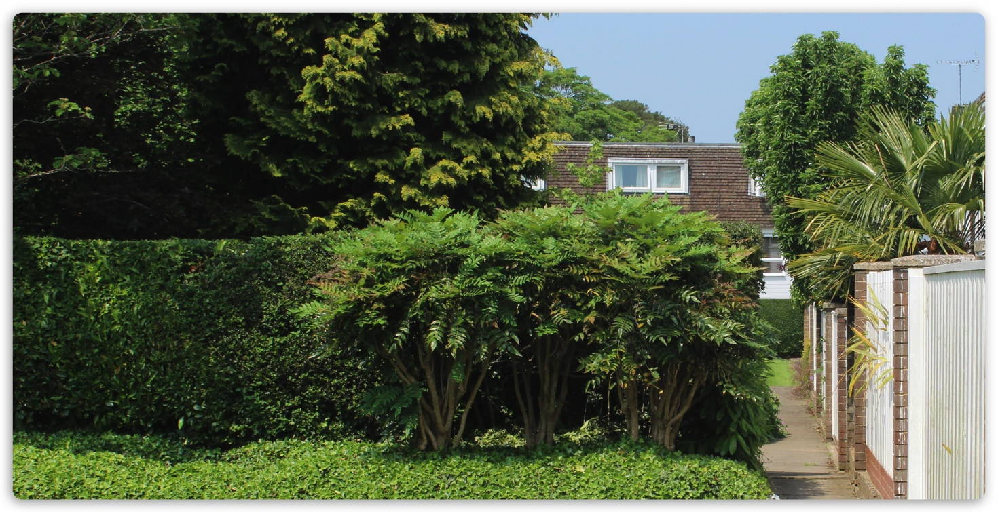

Apologies for the absence of a Spring Newsletter this year, mainly due to the issues surrounding the current COVID-19 situation.

We do hope that all residents have remained well during these very difficult times. However, sadly we have to advise that two of our long term residents have died this year; Rosie Perks who died in March and David Grogan who died in April, both of whom had lived on the Estate in excess of 30 years. Our sincere condolences go out to their family and friends.

AGM
Most shareholders will be aware by now that the AGM at the Baptist Church in Trafalgar Road has now been cancelled and we are looking at viable options for an e-AGM, details of which will be communicated to all shareholders over the next few weeks. If any shareholder wishes to raise any items, please forward them to the Company email address as soon as possible.

Garage Blocks/Townhouse Garages
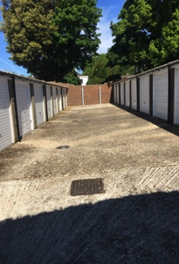
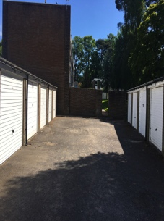

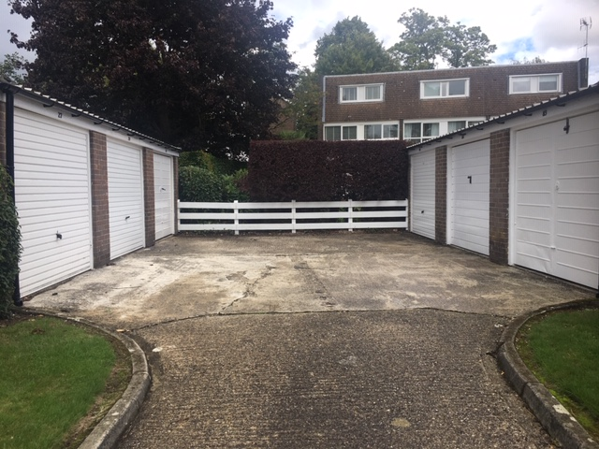
An update on the more positive side of events for the Estate is the completion of the refurbishment of the garage blocks, which included replacement fascias, guttering, numbers and either the repainting/
repairing or complete replacement of the all the garage doors in white. All blocks are now looking far more reputable and brighter/fresher. The broken fence at the back of Garden Walk block has now been replaced and the final resurfacing of Hawthorn Close garage block will take place within the next few weeks. Below are some photos of the blocks. An annual cleaning/ clearing of gutters regime will be introduced next Spring.
However, it is worth bearing in mind that both the Leases/Estate Management Scheme state that repainting of exterior paintwork must be completed every four years. It is the Company’s intention not to let the blocks fall into such a state of disrepair again and a review of garages will be carried out in 2025, which should bring us back in line with the original start date on the EMS/Lease.

This is also a reminder to all townhouse residents to review their garage doors (and frontage in general), some of them are in need of urgent attention. The Company did have to take legal advice regarding one or two owners who were reluctant to commit to the refurbishment, however, our legal representative was able to resolve these issues promptly. Please be advised that the ruling applies to both leasehold and freehold properties.

All other known maintenance issues have also been completed and paid from the Estate Sinking Fund.
Insurance – Flats
Would all owners of empty flats please ensure that the Company is aware and that the electrics are turned off and the flats are inspected for leaks and other issues on a regular basis. Failure to do so, will render the insurance invalid should any accidents/incidents occur

Purchase of Company Garage Lease
We are also very pleased to let you know that there was the biggest ever vote from shareholders regarding the purchase of the Company garage, with a very positive outcome of 82.4% in favour. Our legal advisor has already been advised and we now await finalisation from the current leaseholder. This will be an extremely important asset for the Company. As most of you are aware, it is used for gardener’s equipment, extending ladders for the use of all, and other Estate items.

Notice Boards
It is with regret that we have once again had to increase the number of notice boards on the Estate regarding private property signs at the entrances to the twittens and the no games/ball games signs on the communal grounds. All residents, regardless of status, should have been advised of the Covenants applicable to the Estate prior to moving here and therefore, all are expected to adhere to them, regardless of whether you agree with them or not.

Turning Circle April Close
An electronic survey was carried out for all residents living at the bottom end of April Close following several complaints of damage caused to property by vehicles attempting to reverse in a very congested area and the near miss of an accident involving a small child. This was a very controversial issue in view of the limited parking in the area and the consensus at this time is to not create a turning circle to avoid damage or injury. It is suggested that another notice be placed at the entrance to the area requesting all delivery drivers to park on the road adjacent to AC garage block and deliver their parcels on foot from there. This would not be viable for food home deliveries.

Gardens Surrounding Flats
Please be aware that the land immediately outside of the ground floor balconies belongs to Ashleigh Residents and it is not permitted to plant personal flowers or shrubs or indeed vegetables in these areas. It is also not permitted to place any personal items immediately outside the balconies such as gnomes, bird houses, etc. We would ask all off-site owners to ensure their letting agents/tenants are aware of all restrictions in the Lease. This follows a distressing incident involving a tenant and the majority of the Board. All such items will be removed over the next few months.

A Reminder of Company Fees
Included with this Newsletter is a reminder to all owners of the fees payable to the Company for any changes to the exterior of properties, legal fees for sales, shares, etc. This was originally sent out during the Summer of 2017 and will now be sent out annually as many seem to have mislaid the original.

Complaints from Other Residents
Properties - We receive complaints on regular basis regarding the condition of the front/rear of their neighbours properties and would urge those who are contravening the terms of the EMS to take action to rectify this before the Company is obliged to take the matter further at the expense of all.

Vehicles - We have also received complaints about vehicles left for prolonged periods of time with their engines running. This is not only disturbing to other residents (fumes/noise) both day and night, but is not good for the environment. The Government guidelines are very clear, please see: https://www.gov.uk/government/news/idling-drivers-could-face-higher-fines-under-new-government-crackdown

BBQs/Noise – Probably a little late in the season now, however, during the very warm weather there were many BBQs taking place. As a matter of courtesy would those living in the houses please let their neighbours know when they are intending to BBQ in order for windows to be closed and washing to be taken in. Flat residents – please note BBQs are not allowed on balconies. All should be considerate of their neighbours with regard to noise and allow others to enjoy a more peaceful time on their

Defibrillator

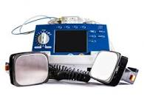
Following a recent personal story regarding the close proximity of one of the above saving a heart attack victim’s life, ARHL is considering investing in a defibrillator for use on the Estate and surrounding area. At this stage we are looking for volunteer first responders who would be willing to undergo training on the machine. The machine would be located in a Company owned cupboard in one of the blocks of flats and all first responders and board members would have access. This would mean that a list of names and phone numbers would be issued in the first instance to all those resident on the Estate, North Ash flats, Ashleigh Road and Fay Close. Volunteers would also, hopefully, be recruited from the whole area. The Company anticipates liaising closely with Horsham First Responders with regard to the purchase of the machine and the training. Anyone interested at this stage, in registering their interest to help, please email us on: info@ashleighresidents.info. A Coordinator would also be required to run the project as the current Board is not in a position to do so.

IT Matters
Our email and website were hosted on a small server situated on the Estate. However, Internet Service Providers have gradually created obstacles to using this server on a domestic internet account. In addition the server itself was struggling to keep up, so we transferred our website to a commercial server. Similarly, company emails are now hosted on a commercial server. Both are now working quickly and efficiently.

Graffiti
And finally, graffiti remover is available from the Board. When next spotted, it would be very much appreciated if the
person concerned would assist the Board with its removal.

